Florida Department of Children and Families
Office of Substance Use and Mental Health
Overdose Prevention Program
Overview

Naloxone, also known as Narcan, is the medication that reverses opioid overdose and saves lives. Opioids include prescription pain medications like hydrocodone and oxycodone, as well as heroin, fentanyl, and other opioids. DCF’s Overdose Prevention Program supplies naloxone to community-based organizations that provide direct services to people at risk of experiencing an overdose. DCF is also implementing a statewide Opioid Overdose Prevention Awareness Campaign – please visit ISAVEFL for more information.

People who use drugs (PWUD) are most likely to witness an overdose and are commonly the first responders at the scene of an overdose – reversing an overwhelming majority of overdoses in the community. Ensuring that PWUD have continuous, low-barrier access to as much naloxone as they need for themselves and their friends is critical in order to save lives from opioid overdose. PWUD should be offered a minimum of 5 naloxone kits at a time, with the option to receive more or take less, so they can provide naloxone kits to their friends who may also be in need.

Requirements

Organizations requesting naloxone kits from DCF must meet the following requirements. Completed documentation can be submitted via email to Amanda.Muller@myFLfamilies.com

- Receive an initial harm reduction training from DCF (in person or via webinar)
- Agree to distribute free naloxone kits directly to people who use drugs, people with a history of drug use, others at risk of experiencing an overdose, and/or to friends/family that are likely to witness an overdose
- Identify a pharmacy licensed in the State of Florida to receive shipments of naloxone and submit a copy of the pharmacy license
- Submit Appendix A - Narcan Signature Authorization Form
- Submit Appendix B - Narcan Order Form
- Provide a brief description (1-3 sentences) of how the organization plans to distribute Narcan / who Narcan kits will be offered and distributed to
- Submit Appendix C - Narcan Distribution Monthly Reports by the 15th of each month

Sample Policies

Organizations may need to operate under a non-patient specific naloxone standing order, signed by a licensed prescriber, to hand out naloxone kits directly to individuals at risk of witnessing or experiencing an opioid overdose. A sample standing order policy is included as Appendix D. Please review with your organization to determine if this policy is needed.

Restrictions

Due to limited funding, DCF naloxone kits cannot be distributed to law enforcement/EMS/Fire departments. However, these agencies can receive naloxone from DCF for “leave behind” programs, where free naloxone kits are left behind at the scene of an overdose with the person who overdosed and their friends/family.

DCF Contact Information

Amanda Muller – Overdose Prevention Coordinator – Amanda.Muller@myFLfamilies.com – 850-631-0212
APPENDIX A
Narcan Signature Authorization Form
Florida State Hospital

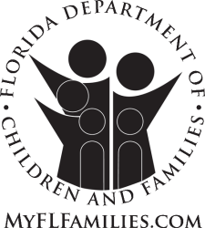
Ron DeSantis
Governor

Chad Poppell
Secretary

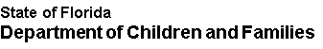

Please list the individuals at your organization who will place orders for Narcan.
Name | Facility | Signature | Date

SIGNATURE OF APPROVAL: _____________________

TITLE: _____________________

DATE _____________________

(Needs to be approved by supervisor of highest-level employee listed above)
Florida State Hospital
100 North Main Street/POB 1000 Chattahoochee, Florida 32324-1000
Mission: Work in partnership with local communities to protect the vulnerable, promote strong and economically self-sufficient families, and advance personal and family recovery and resiliency

If you require Americans with Disabilities Act accommodations to participate in an event at Florida State Hospital, please notify Human Resources at (850) 663-7585 at least seven (7) days prior to the event. Deaf or hard of hearing individuals may call 1-800-955-8771.

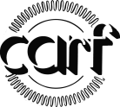
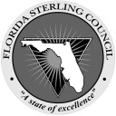

- F ACCREDITED GOVERNOR’S STERLING AWARD RECIPIENT

APPENDIX B

Narcan Order Form

Instructions:

Email completed order forms to Amanda.Muller@myFLfamilies.com

Only complete the sections highlighted in yellow - write the number of Narcan kits being requested under “quantity”, write the pharmacy address, and sign/date the form. Orders can be placed as needed. Allow 1-2 weeks after submitting an order to receive your shipment.

NARCAN Nasal Spray is the naloxone product DCF currently has available. Each Narcan kit comes with 2 doses, and each dose is 4mg/0.1mL. Instructions on how to use the Narcan are printed on the kit and on the “Quick Start Guide” included in each kit.

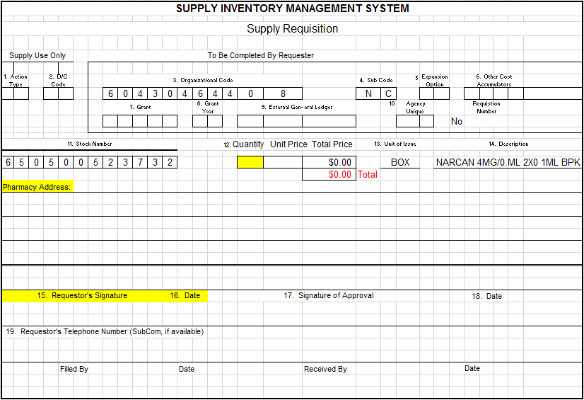

APPENDIX C
Narcan Distribution Monthly Report

Instructions:

Email completed monthly reports to Amanda.Muller@myFLfamilies.com

Due Date: Reports are due by the 15th of each month to report on activities from the previous month. Example: a report for the month of May is due by June 15th and will report Narcan kits distributed and overdose reversals reported during May 1 – 31.

Reporting Month: In the chart below, report the number of Narcan kits distributed to people at risk of overdose and their friends/family, and the number of overdose reversals reported, during the reporting month. Example: if 100 Narcan kits were distributed during the month of May, then write “100” next to “Reporting Month” for “Number of Narcan Kits Distributed” on the May report.

Total to Date: In the chart below, report the number of Narcan kits distributed to people at risk of overdose and their friends/family, and overdose reversals reported, since your organization started distributing Narcan from DCF through the most recent reporting period (this is a cumulative total that gets added to each month as you continue distributing Narcan). Example: if your organization began distributing Narcan in April, and 100 kits were distributed in April and 100 kits were distributed in May, then write “200” next to “Total to Date” for “Number of Narcan Kits Distributed” on the May report.
__________________________________________________________________________________________

Reporting Month and Year:

Organization Name:

Point of Contact:
Email:
Phone:

 | Number of Narcan Kits Distributed | Number of Overdose Reversals Reported to Organization | Number of Overdose Reversals that Occurred On-Site by Staff (bathroom, parking lot, etc.)
Reporting Month
Total to Date
Provide any notes, questions, successes, challenges/barriers, or feedback:

APPENDIX D

[ORGANIZATION NAME]
Overdose Prevention and Education Program

Non-Patient Specific Naloxone Standing Order

Naloxone hydrochloride is indicated for the reversal of opioid overdose. Individuals experiencing an opioid overdose may be unresponsive and experiencing respiratory arrest or respiratory depression. Do not administer naloxone to someone who is awake/responsive. It is contraindicated in patients known to be hypersensitive to naloxone hydrochloride. Naloxone is not a substitute for emergency medical care. Naloxone only lasts for 30-90 minutes. After naloxone administration, a person may return to respiratory depression once the medication wears off – always get help immediately. The use of naloxone may result in symptoms of acute opioid withdrawal. This non-patient specific naloxone standing order (referred to as “standing order”) will be reviewed carefully against the most current recommendations and may be revised by the authorized prescriber.

This standing order covers the possession and distribution of naloxone kits for the [ORGANIZATION NAME] Overdose Prevention and Education Program, in compliance with Chapter 381.887, Florida Statutes.

- This standing order authorizes employees and volunteers of [ORGANIZATION NAME] to pick up naloxone kits from a pharmacy, maintain supplies of naloxone kits, and to distribute free naloxone kits directly to people who use drugs, people with a history of drug use, others at risk of experiencing an overdose, and to friends/family that may witness an overdose.

- Prior to distributing naloxone, employees and volunteers of [ORGANIZATION NAME] will offer education to individuals on the proper use of the medication. Narcan Nasal Spray kits have instructions printed on the box and a Quick Start Guide in each kit. Additional education or training can be offered, but is not required, and should not act as a barrier to someone receiving naloxone.
- Signs/symptoms of opioid overdose
- Assessment with sternal rub
- Administer naloxone and call 911
- Naloxone onset (2 – 3 minutes), duration (30 – 90 minutes), and side effects (withdrawal)

People to Receive Naloxone Kits (Organizations should edit this section to reflect who they will be distributing naloxone to.)

The following people are authorized to receive free naloxone kits under this standing order:

- People who use drugs
- People who have previously experienced a drug overdose
- People entering, enrolled, or being discharged from substance use disorder treatment services, including detox, inpatient, residential, outpatient, abstinence-based treatment programs, or aftercare
- People entering, enrolled, or being discharged from methadone, buprenorphine/suboxone, and naltrexone/Vivitrol programs
- People on a waitlist or call-back list to receive substance use treatment services, especially those seeking treatment for opioid use disorder
- People with a history of drug use who may be currently abstaining from drugs
- People receiving recovery support services
- People who inject drugs
- People participating in a syringe exchange program
- People currently experiencing homelessness / people without stable housing
- People re-entering the community from jail or prison
- People with a prescription for opioid pain medication, such as oxycodone, hydrocodone, or other opioids
- Family members, friends, or others who know someone at risk for opioid overdose and are likely to witness an opioid overdose
- Others likely to experience or witness an opioid overdose

Order to Distribute

Distribute free naloxone kits directly to any of the groups mentioned above. People who are actively using drugs should be offered a minimum of 5 naloxone kits (with the option to request more or take less) so they can provide kits to their friends that may use drugs/are at risk of overdose.

Naloxone kits should include at a minimum:
- Two devices of NARCAN® Nasal Spray
- Instructions on how to use NARCAN® Nasal Spray (instructions are included in each Narcan kit – additional materials are not required)
Directions for Administration

Administer NARCAN® Nasal Spray to a person believed to be experiencing an opioid overdose with respiratory depression or unresponsiveness as follows:

- Activate emergency medical services / call 911
- If indicated, initiate rescue breathing
- Push the middle portion of the NARCAN Nasal Spray device to spray 4mg of naloxone into one nostril
- Continue rescue breathing and monitor respiration and responsiveness of NARCAN recipient
- If no response after 2-3 minutes, administer the second dose of NARCAN Nasal Spray into the alternate nostril, and repeat Step 4
- When emergency medical services arrive, inform personnel that NARCAN has been administered to the individual.

___________________________________ _________________________
Prescriber’s Name (Print) Prescriber’s Signature

___________________________________ __________________________
Prescriber’s License Number Effective Date of Standing Order

