Subject - Center for Excellence for Integrated Health Solutions - Bring Workforce Solutions to Scale – partnership/grant opportunity – April 2020

April 7, 2020
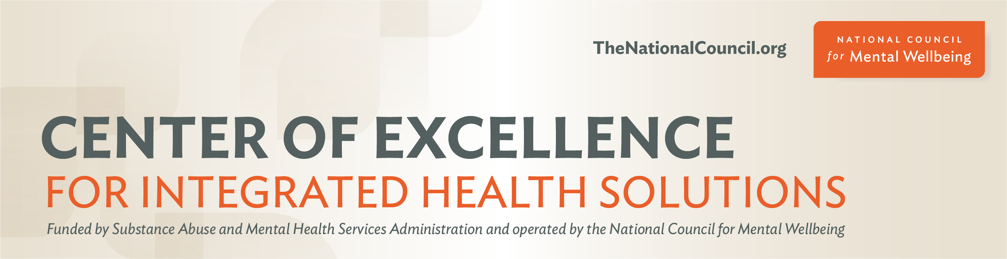
Now more than ever, integrated whole-person care is critical to address the rising demand for mental health care, substance use treatment and general health care services. However, your organization is likely facing major challenges due to the COVID-19 pandemic, including problems with recruitment and retention, as well as staff burnout. For many, the shortage of workers has caused longer wait lists and has forced some organizations to reduce services at a critical time when demand is still on the rise.
Let’s work together to build workforce solutions that cross cultural, geographical and population specific barriers.
We are excited to extend the opportunity to 30 integrated care organizations to partner with the Center for Excellence for Integrated Health Solutions (CoE-IHS) in a groundbreaking new Learning Collaborative, Workforce Innovations in Integrated Care Collaborative. Participating organizations will partner with the CoE-IHS to receive $25,000 and ongoing support to develop and implement innovative solutions to address integrated care workforce challenges. This learning opportunity will launch in late May and conclude with a virtual session in July.

Apply Today

Applications are due by 11:59 p.m. ET on Friday, April 15. Hurry to get your applications in! They will be reviewed on a first-come, first-served basis.
Have questions or want to learn more? Join us for an office hour session with integrated care experts on Thursday, April 7, 2-3 p.m. ET to have your questions answered. You can also learn more about this opportunity in our Frequently Asked Questions (FAQ) document.

Register for the Office Hour

This Learning Collaborative is supported by the Center of Excellence for Integrated Health Solutions (CoE-IHS), funded by a grant award from the Substance Abuse and Mental Health Services Administration (SAMHSA). If you have any questions about this opportunity, please contact Integration@TheNationalCouncil.org.
Subscribe today for CoE-IHS updates.

