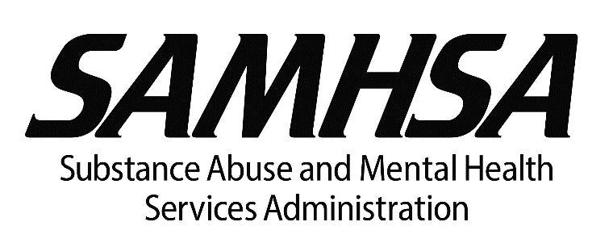

As Part of President Biden’s Mental Health Strategy, HHS Awards Nearly $105 Million to States and Territories to Strengthen Crisis Call Center Services in Advance of July Transition to 988

Funded by the American Rescue Plan, these investments will bolster our crisis care infrastructure

Washington, D.C. Tuesday, April 19, 2022 –

The Department of Health and Human Services (HHS), through its Substance Abuse and Mental Health Services Administration (SAMHSA), is awarding nearly $105 million in grant funding, provided by the American Rescue Plan, to 54 states and territories in advance of the transition of the National Suicide Prevention Lifeline from the current 10-digit number to the 988 three-digit dialing code in July. Strengthening our crisis care infrastructure is a core priority of President Biden’s Mental Health Strategy, which he announced at the State of the Union as part of his national Unity Agenda. Improving 988 readiness and responsiveness is a critical step to realizing this objective.
States and territories are expected to use the funds to improve response rates, increase capacity to meet future demand, and ensure calls initiated in their states or territories are first routed to local, regional, or state crisis call centers. Award recipients may also use the funds to build the workforce necessary for enhancing local text and chat response. These grants along with other recent funding from the administration, represent a 40-fold increase in federal support of the Lifeline over the past four years. With states at varying degrees of operational readiness, the success of 988 now rests heavily on the willingness of state, territorial, and local leaders to make additional investments in shoring up the crisis care continuum.
“Providing states and territories with the support to prevent suicide by assisting people in crisis is critical to our nation’s health,” said HHS Secretary Xavier Becerra. “It is imperative that states and territories partner closely with HHS to ensure the highest level of 988 contact response.”
“Preparing for the transition to 988 is a top priority for SAMHSA,” said Miriam Delphin-Rittmon, Ph.D., the HHS Assistant Secretary for Mental Health and Substance Use and the leader of SAMHSA. “Not only will we continue working with our federal and national stakeholders to achieve a smooth transition, but these grants demonstrate that states and territories are also critical partners in this effort.”

Read More

