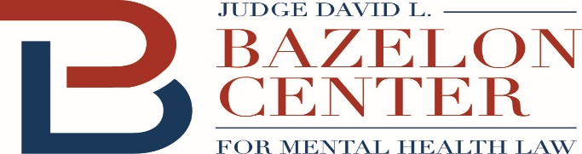
New Funding is Available for Community-Based Mental Health Services

The new COVID-19 relief bill – the American Rescue Plan, H.R. 1319 – provides new federal funding for community-based mental health services.
Section 9817 of the American Rescue Plan, which went into effect on April 1, increases the amount of federal reimbursement available under the Medicaid program for one year for what the law calls Home and Community Based Services (HCBS). There may be future legislation that extends this funding.
The law adds an additional 10% to the federal “match” rate. If a state’s match rate was 60% (the federal government paid 60% of the cost), for example, the new match rate would be 70% (with the federal government paying 70% of the cost). The new match cannot be more than 95%.
HCBS are services that help people live and participate in the community -- like intensive case management, peer support services, assertive community treatment, skills training, and supported employment. These services also help individuals avoid criminal justice involvement and may be used to divert people from jail or other congregate settings, and to facilitate re-entry.
The enhanced match can be used for mobile mental health crisis teams, including as an alternative to the new funding option for such services created in a separate provision of the law. In the American Rescue Plan, what is encompassed by the term HCBS extends beyond services previously labelled as “HCBS” in Medicaid. Among other things, HCBS includes, and the enhanced match applies to:
1. case management services,
2. mental health rehabilitative services, which encompasses a broad range of skill building and other services such as assertive community treatment, peer support services, and services to help individuals secure and maintain housing,
3. services in a waiver (including a Section 1115 Medicaid demonstration waiver) or provided through the Section 1915(i) option, such as supported employment and start-up costs for individuals transitioning to community housing, which may include security deposit, furniture, and utility startup, and
4. “[s]uch other services specified by the Secretary of Health and Human Services.”
The new funding is meant to expand existing service capacity by supplementing what states now spend on community-based services. The law provides that the “State shall use the Federal funds … to supplement, and not supplant, the level of State funds expended for home and community-based services for eligible individuals through programs in effect as of April 1, 2021,” and that the “State shall implement, or supplement the implementation of, one or more activities to enhance, expand, or strengthen home and community-based services under the State Medicaid program.” It is estimated that the enhanced match could generate nearly $13 billion in new services.
States can use the new resources to reduce the number of individuals in congregate settings, through diversion and discharge, especially where there is a continuing risk of COVID transmission.
The U.S. Department of Health and Human Services may provide further guidance on use of the funds in the future.
See American Rescue Plan (Section 9817) at https://www.congress.gov/117/bills/hr1319/BILLS-117hr1319enr.pdf.

Defunding” the Police: and People with Mental Illness, Bazelon Center for Mental Health Law (Aug. 2020), http://www.bazelon.org/wp-content/uploads/2020/08/Defunding-the-Police-and-People-with-MI-81020.pdf; Diversion to What? Evidence-Based Mental Health Services That Prevent Needless Incarceration, Bazelon Center for Mental Health Law (Sept. 2019), https://secureservercdn.net/198.71.233.254/d25.2ac.myftpupload.com/wp-content/uploads/2019/09/Bazelon-Diversion-to-What-Essential-Services-Publication_September-2019.pdf; Martone et al., Olmstead at 20: Using the Vision of Olmstead to Decriminalize Mental Illness (Sept. 2019), https://www.tacinc.org/wp-content/uploads/2020/02/olmstead-at-twenty_09-04-2018.pdf.
An Alternative to the Police: New Funding is Available for Mobile Mental Health Crisis Teams, Bazelon Center for Mental Health Law (April 2021), https://secureservercdn.net/198.71.233.254/d25.2ac.myftpupload.com/wp-content/uploads/2021/04/ARP-mobile-crisis-provisions-final.pdf.
When Opportunity Knocks: How the Affordable Care Act Can Help States Develop Supported Housing for People with Mental Illnesses, Bazelon Center for Mental Health Law 15-16 (April 2014) (discussing 1915(i) option), http://www.bazelon.org/wp-content/uploads/2017/01/When-Opportunity-Knocks.pdf.

