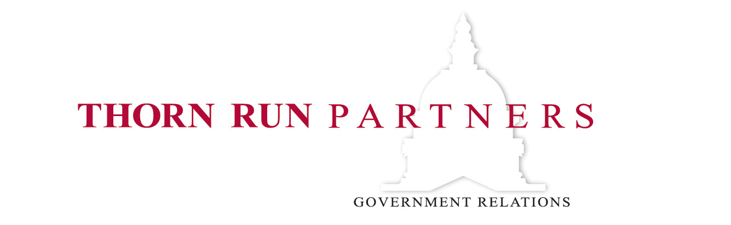
Memorandum
March 17, 2020

Leave Policies Under Coronavirus Relief 2.0

Introduction

On March 13, 2020, the House of Representatives passed a bill that includes limited paid sick and family leave for individuals impacted by the COVID-19 outbreak. On March 16, the House passed a set of technical corrections to the legislation prior to transmitting it to the Senate. Senate Majority Leader Mitch McConnell (R-KY) has announced that the Senate will take up the legislation as-is in the coming days.

Both provisions are limited to individuals directly affected by COVID-19, whether caring for themselves or others, and they take effect no later than 15 days after enactment and sunset on December 31, 2020. The provisions apply to employers with fewer than 500 employees, and the Department of Labor can exempt certain small businesses with fewer than 50 employees, as may health care workers and emergency responders. Employers may claim 100 percent of wages paid to employees in connection with the COVID-19-related leave requirements as a refundable tax credit. This memo is drafted to apply to private-sector employers and employees and is not intended to inform public-sector entities or as legal advice.

Max Benefits per Employee by Income
Annual Employee Income (40 Hours per Week, 52 Weeks per Year |  | Sick Leave Benefit (10-Day Max) |  | Family Leave Benefit (10-Week Max) | Max per Employee
 |  | Self — 100 Percent Wages ($511 Daily Cap) | Caregiver — 2/3 Wages ($200 Daily Cap) | 2/3 Wages ($200 Daily Cap)
Federal Minimum Wage | $15,080 | $580 | $387 | $1,933 | $2,513
Poverty Level (Family of Four) | $26,200 | $1,008 | $672 | $3,359 | $4,367
Median Income for Full-Time Workers | $48,672 | $1,872 | $1,248 | $6,240 | $8,112
Income for Max Sick Leave for Caregiving and Family Leave | $77,997 | $3,000 | $2,000 | $10,000 | $13,000
Income for Max Sick Leave for Self | $132,900 | $5,110 | $2,000 | $10,000 | $15,110

Paid Sick Leave

Benefit
Covered employers must provide 80 hours of sick time for full-time employees, pro-rated based on work schedule for part-time employees. Employees that are eligible for sick leave under this legislation fall into two categories for the purpose of determining the benefit:

- Those that are subject to a federal, state, or local quarantine or isolation order related to COVID-19, those advised by a health care provider to self-quarantine due to COVID-19, and those experiencing symptoms of COVID-19 and are seeking a medical diagnosis; and
- those that are caring for an individual under mandatory quarantine or advised self-quarantine or are caring for a son or daughter whose school or place of care has been closed due to COVID-19. Sick time under the legislation is terminated as soon as an employee’s reason for taking it is no longer the case. Employers must post a notice about the benefit in the workplace. They may not require that employees find their own replacement.

For individuals in category 1 taking sick leave, benefits are capped at $510 per day and $5,100 in aggregate. For individuals in category 2 taking sick leave, benefits are capped at $200 per day and $2,000 in aggregate.

For individuals in category 1 taking paid sick leave, payment under this legislation is calculated based on compensation and number of work hours. Payment must be at least minimum wage. For individuals in category 2, payment under this legislation would be 2/3 of the required amount for individuals in category 1.

The following are key components of the two weeks of paid sick leave:

Covered Employers
- Employers with fewer than 500 employees must provide the paid sick leave benefit for COVID-19. The Secretary of Labor may exempt small businesses with fewer than 50 employees if the policy would jeopardize the viability of the business as a going concern.

- This legislation appears to apply to employers who already have paid sick leave policies in place; i.e., they should be eligible for tax credits for paid sick leave related to COVID-19.

- Employers that are part of a multi-employer collective bargaining agreement (CBA) may administer the benefit through the CBA.

- Covered employers who do not offer paid sick leave are considered to have failed to pay minimum wage, and covered employers who terminate employees for taking leave are considered in violation of the Fair Labor Standards Act. Penalties include fines and imprisonment.

Covered Employees
- As a general rule, this policy applies to all employees. Self-employed individuals are also eligible for a similar benefit.

- Employers may choose to exempt employees who are health care workers or emergency responders from paid sick leave requirements. The Secretary of Labor is directed to issue regulations implementing this exemption.

Tax Credit
- Wages subject to the cap limitations and health plan premiums may be claimed as fully refundable tax credits against the employer portion of payroll taxes. Credits for health plan premiums are not capped. Employers’ payments to employees are still taxable income and subject to employee-side payroll taxes.

Paid Family Leave

Benefit
Covered employees would be eligible for 10 weeks of paid leave under the legislation. Individuals who are unable to work or telework due to needing to care for their minor child whose school or place of care being closed due to COVID-19 are eligible for this leave. Employers may impose a two-week unpaid leave period at the outset, though employees may use any other accrued paid leave (including the paid sick leave included in this legislation, it appears) in lieu of those two weeks. Pay during the ten-week period of paid leave is not less than two-thirds of an employee’s regular rate of pay, based on hours the employee would have worked. The benefit is capped at $200 per day or $10,000 in aggregate.

Individuals taking leave will be restored to their previous position unless:

- the employer has fewer than 25 employees,
- the position no longer exists, and
- the employer makes reasonable efforts to restore the employee to an equivalent position.

If such efforts fail, then employers must make an effort to contact the employee for one year should an equivalent position become available.

The following are key components of the 10-week paid family benefit:

Covered Employers
- Employers with fewer than 500 employees must provide the paid family leave benefit for COVID-19. The Secretary of Labor may exempt small businesses with fewer than 50 employees if the policy would jeopardize the viability of the business as a going concern.

- Employers that are part of a multi-employer collective bargaining agreement (CBA) may administer the benefit through the CBA.

- This legislation appears to apply to employers who already have paid family leave policies in place; i.e., they should be eligible for tax credits for paid sick leave related to COVID-19.

- Covered employers who do not offer this benefit would be considered to be in violation of the Family and Medical Leave Act, which may be enforced by civil action by employees or by administrative or civil action by the Secretary of Labor.

Covered Employees
- Employees who have been employed for at least 30 days by their current employer are eligible for this benefit. Self-employed individuals are also eligible for a similar benefit.

- Employers may choose to exempt employees that are health care workers or emergency responders from paid family leave requirements. The Secretary of Labor is directed to issue regulations implementing this exemption.

Tax Credit
- Wages subject to the cap limitations and health plan premiums may be claimed as fully refundable tax credits against the employer portion of payroll taxes. Credits for health plan premiums are not capped. Employers’ payments to employees are still taxable income and subject to employee-side payroll taxes.

