**From:** Paul Curtis <[pcurtis@cccbha.org](mailto:pcurtis@cccbha.org)>   
**Sent:** Monday, August 12, 2019 11:27 AM  
**To:** Jeannie Campbell <[JeannieC@TheNationalCouncil.org](mailto:JeannieC@TheNationalCouncil.org)>  
**Cc:** Doyle Forrestal <[dforrestal@cbhc.org](mailto:dforrestal@cbhc.org)>  
**Subject:** Palm Springs - Things To Do

**Hi Jeanne. Hope you had a great weekend.   Below is the best list I found of the Top 10 things to do in the Palm Springs area.**

**For those who might go early or stay after the Board meeting the Thursday night street market called Village Fest is a lot of fun and will be in full swing in November.**

**I highly recommend the Living Desert Zoo and Gardens, and the Tram, especially for Board members who won’t be on the AE trip.**

**For those who might have an extra day to explore I highly recommend Joshua Tree National Park as well.**

**I hope this helps.  Paul**

------------------------------------------------------------------------------------------------------------

**10 Top-Rated Tourist Attractions in Palm Springs**

[Written by Lana Law](https://www.planetware.com/lana-law-bio.htm)

Set in the Colorado Desert, just two to three hours from [San Diego](https://www.planetware.com/tourist-attractions-/san-diego-us-ca-sd.htm) and [Los Angeles](https://www.planetware.com/tourist-attractions-/los-angeles-us-ca-la.htm), Palm Springs is a sunny vacation destination known for its wonderful golf resorts, warm weather, and fun vibe. The city, along with several other surrounding communities, including Palm Desert, is a winter getaway destination for many Americans. Beyond the golf resorts there are still plenty of things to do, from shopping, dining, and touring museums to exploring the surrounding mountains and canyons.

**1 Palm Springs Aerial Tramway and Mount San Jacinto**

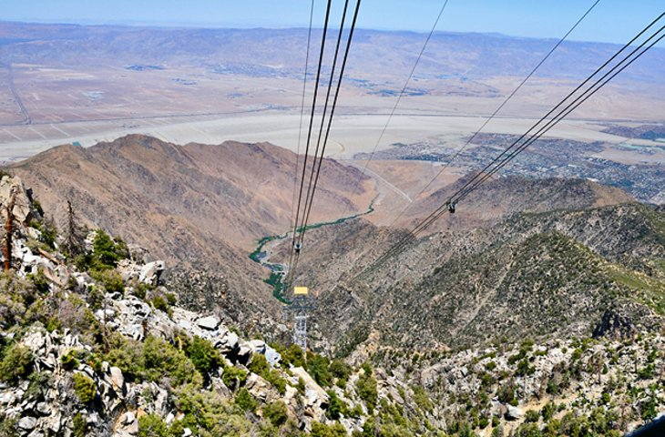

Palm Springs Aerial Tramway and Mount San Jacinto

Standing on the edge of Palm Springs, Mount San Jacinto rises more than 10,000 feet above the desert floor and can be easily accessed with the scenic Aerial Tramway, the world's largest rotating aerial tram car. The view out over the desert is fantastic, and on hot days the cool air at the top can be a refreshing treat.

The tram will take you to 8,500 feet, where there are observation decks, two restaurants, historical displays, and videos on the construction of the tram. From here, a number of hiking trails run through the pine forest, including a trail to the summit of San Jacinto. The temperature is considerably cooler up here, even in summer, so if you are here in winter be prepared for the possibility of snow.

The trams run every thirty minutes, and the ride time is about 10 minutes.

Address: One Tram Way, Palm Springs, California

Official site: <https://www.pstramway.com/>

**2 Palm Springs Air Museum**

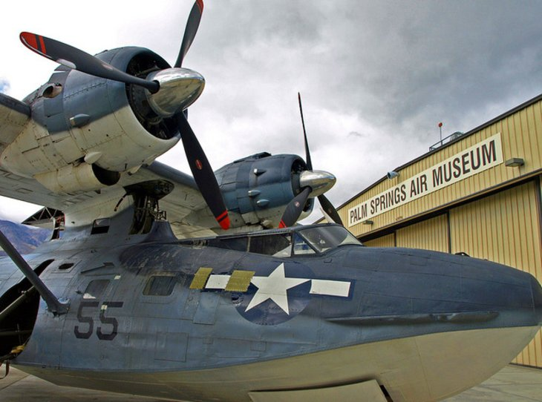

Palm Springs Air Museum [Rex Brown](http://www.flickr.com/photos/maduko/) / photo modified

The Palm Springs Air Museum is known for having one of the country's largest collections of working Second World War period aircrafts. Despite this, the museum is quite compact and can be explored easily in a relatively short period of time. Much of the collection is displayed in hangars, so it's a great place to visit when the weather is too hot to be outside or if you're looking for an escape from the outdoors.

Address: 745 North Gene Autry Trail, Palm Springs, California

Official site: <http://palmspringsairmuseum.org/>

**3 Indian Canyons**

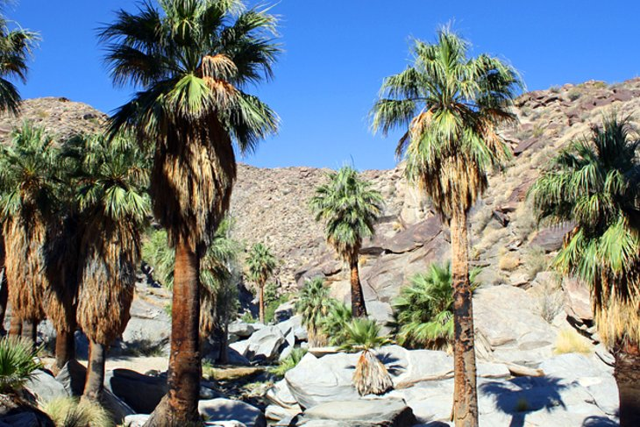

Indian Canyons

Indian Canyons, just outside Palm Springs, is a popular area for hiking and exploring some beautiful desert scenery. One of the most scenic sections is found at **Palm Canyon**. This 15-mile long canyon, with a creek and waterfalls, is lined with large palm trees that bring color to the otherwise muted shades of the desert surroundings. You can go for a short stroll to the creek or continue on for a longer hike, enjoy a picnic, or simply soak up the tranquility. From the parking lot, trails of various lengths lead out into the oasis. On-site is a Trading Post selling souvenirs, Indian art, and other items.

Andreas Canyon, another oasis, is also worth checking out and a good place to see birds. In the same vicinity is Murray Canyon, with a less frequented hiking trail and better opportunities for spotting deer and other wildlife.

Accommodation: [Where to Stay in Palm Springs](http://www.jdoqocy.com/click-2339553-10775740?URL=http%3A%2F%2Fwww.tripadvisor.com%2FSmartDeals-g32847-a_cja.10775740-a_cjp.2339553-m13092-Palm_Springs_California-Hotel-Deals.html)

**4 Golfing**

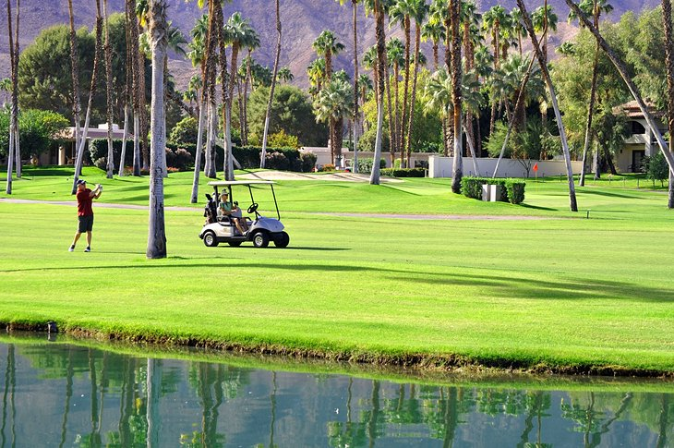

Golf course in Palm Springs

Palm Springs and nearby Palm Desert have some lovely golf courses, and during the winter months, when temperatures are perfect for a round of golf, tourists flock to the area on golf vacations. The courses are extremely scenic, with arid mountains rising in the distance beyond the green fairways that contrast starkly with the surrounding desert. Courses range in quality and price, but some of the top names for public golf courses in the area include Indian Canyons Golf Resort, Escena Golf Club, Desert Willow Golf Resort, [Marriott's Shadow Ridge](http://www.jdoqocy.com/click-2339553-10842362?URL=http%3A%2F%2Fwww.tripadvisor.com%2FHotel_Review-s1-g32846-d223892-Reviews-a_cja.10842362-a_cjp.2339553-m13092-Marriott_s_Shadow_Ridge_I_The_Villages-Palm_Deser.html), and Classic Club.

**5 Palm Springs Art Museum**

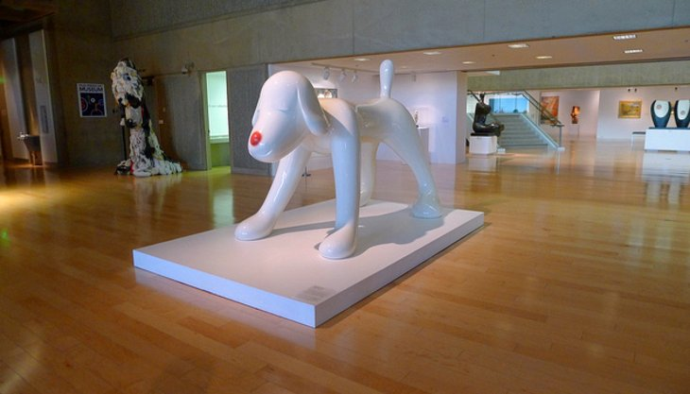

Palm Springs Art Museum

The Palm Springs Art Museum is a multifaceted museum featuring artwork and performing arts. The museum has been in existence since the late 1930s and formerly focused almost exclusively on the desert, but over the years the direction has shifted to modern and contemporary art, including Native American art. The collection includes works by Pablo Picasso, Andy Warhol, Henry Moore, Marc Chagall, and Ansel Adams, among others. Also on site are two outdoor sculpture gardens. Permanent collections include paintings, photography, glass, pottery, and architecture and design.

Address: 101 Museum Drive, Palm Springs, California

Official site: <https://www.psmuseum.org/>

**6 Coachella Valley Preserve**

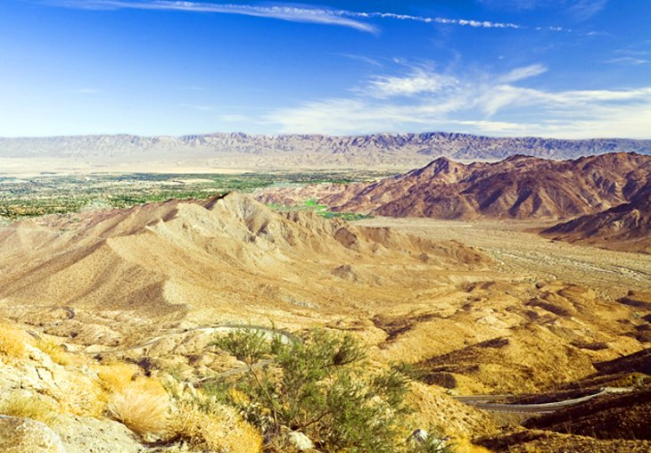

Coachella Valley Preserve

East of Palm Springs, the Coachella Valley Preserve is another wonderful natural area to explore in the Palm Springs area. The preserve covers 13,000 acres of desert landscape and is home to a variety of wildlife, including great horned owls, lynx, hares, kestrels, lizards, snakes, and all kinds of small birds. Guided hikes by volunteers are a great way to see the preserve and offer an excellent overview of the area. If you are just looking to enjoy some tranquility, you can also tackle one of the self-guided hiking trails.

Official site: <http://coachellavalleypreserve.org/>

**7 Moorten Botanical Gardens**

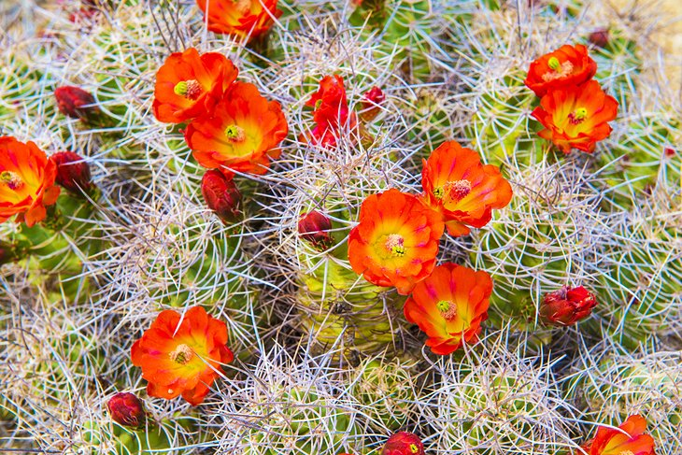

Mojave mound cactus

Moorten Botanical Gardens offers an incredible display of cacti and desert plants that range from full grown trees to plants just taking root. In the spring, when the desert is coming into bloom and trees are starting to turn green again, the gardens are at their best. The facility is open year-round but during the cooler months, from fall until spring, you can take a guided tour of the facility offered free with admission.

Address: 1701 S. Palm Canyon Drive, Palm Springs, California

Official site: <http://moortenbotanicalgarden.com/>

**8 The Living Desert Zoo and Gardens**

A visit to the Living Desert Zoo and Gardens in Palm Desert offers a chance to see the flora and fauna of the Colorado Desert and gain some insight into ecosystems from deserts around the globe. The zoo features a variety of animals from [North America](https://www.planetware.com/north-america-travel.htm)and [Africa](https://www.planetware.com/africa-middle-east-travel.htm), including coyotes, wolves, foxes, badgers, mountain lions, raptors, zebras, giraffes, hyenas, leopards, gazelle, and many other species. The morning is generally the best time, before the heat sets in and the animals are still active. Check the zoo's daily schedule to find out about guided nature walks, wildlife shows, and animal feeding times.

Address: 47900 Portola Avenue, Palm Desert, California

Official site: [www.livingdesert.org](http://www.livingdesert.org/)

**9 VillageFest**

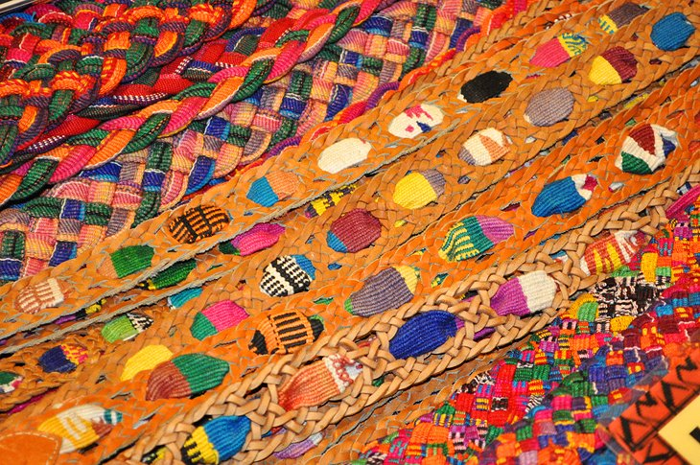

Belts for sale at Villagefest [Joe Bielawa](https://www.flickr.com/photos/joebielawa/)/ photo modified

On Thursday evenings, downtown Palm Springs comes to life with more than 180 vendors set up in the streets for VillageFest. Palm Canyon Drive is closed to traffic, and booths are set up along both sides of the street. This is a fun evening out, where you can shop for arts, crafts, jewelry, and other interesting trinkets and try some tasty snacks from local restaurants and stores. Musical performers, buskers, and other acts provide additional entertainment. The event starts early in the evening, around 6 or 7pm, depending on the season, and runs until 10pm.

Official site: <http://villagefest.org/>

**10 Palm Springs Art Museum Architecture and Design Center**

This is a unique and free attraction that is worth a stop, particularly if you are interested in architecture. Located in a mid-century International Style building, similar in style to many other buildings in Palm Springs that still remain from this period, the structure is a protected historic site.

The Architecture and Design Center holds the architecture collections of the Palm Springs Art Museum and features temporary exhibitions. Exhibits are well laid out and easy to understand, and staff are always on hand to answer questions.

Address: 101 Museum Drive, Palm Springs, California

Official site: <https://www.psmuseum.org/architecture-design-center/>

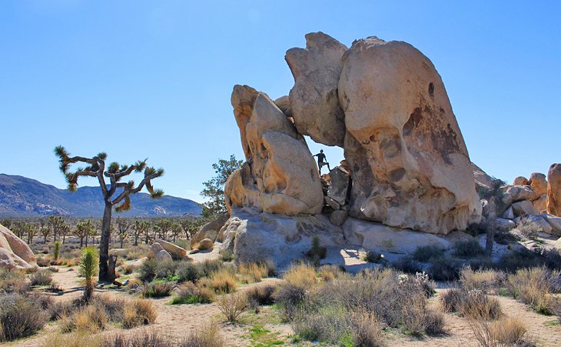

Joshua Tree National Park

Less than an hour's drive from Palm Springs is [Joshua Tree National Park](https://www.planetware.com/desert-area/joshua-tree-national-park-us-ca-jtnp.htm), one of the most interesting and beautiful parks in the Southwest. If you have time for only one side trip, this is the place to come. This park has some amazing sites and great walks and also offers [outstanding campgrounds](https://www.planetware.com/california/best-campgrounds-in-joshua-tree-national-park-camping-details-us-ca-162.htm), where you can park your RV or pitch your tent next to huge Joshua trees and giant rock formations.

Paul Curtis

Executive Director

California Council of Community Behavioral Health Agencies

455 Capitol Mall, Suite 315, Sacramento, CA 95814

916-557-1166  x.10

[pcurtis@cccbha.org](mailto:pcurtis@cccbha.org)

[](https://www.cccbha.org/)[600px-Facebook_logo](https://www.facebook.com/cccbha/) [Twitter-icon_circle](https://twitter.com/CBHA_Updates) [Instagram_logo_circle](https://www.instagram.com/cccbha/) [Linkedin_circle](https://www.linkedin.com/company/ca-council-of-community-mental-health-agencies)

[](https://www.cccbha.org/bhcalcon)  
CONFIDENTIALITY NOTICE: This email and any files transmitted with it are confidential and intended solely for the use of the individual or entity to whom they are addressed. If you have received this email in error please notify the system manager. This message contains confidential information and is intended only for the individual named. If you are not the named addressee you should not disseminate, distribute or copy this e-mail. Please notify the sender immediately by e-mail if you have received this e-mail by mistake and delete this e-mail from your system. If you are not the intended recipient you are notified that disclosing, copying, distributing or taking any action in reliance on the contents of this information is strictly prohibited.