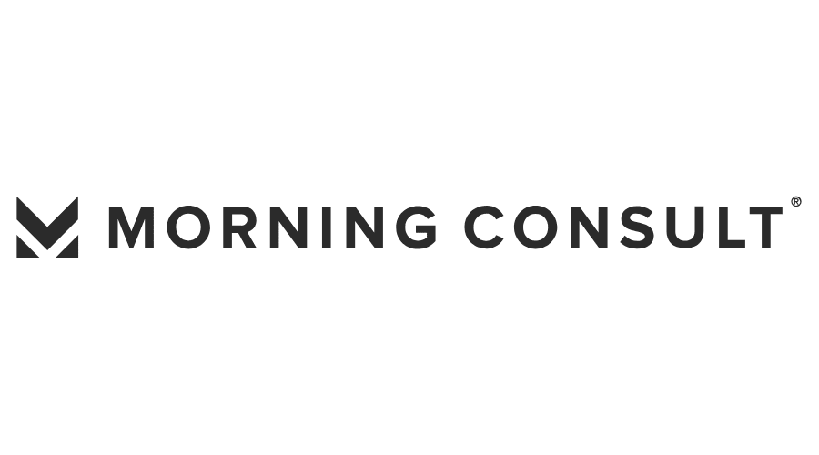

September 9, 2020

In September, the National Council surveyed CEOs of community behavioral health care organizations nationwide and found demand for services is increasing while their financial viability and capacity to deliver care is decreasing due to COVID-19