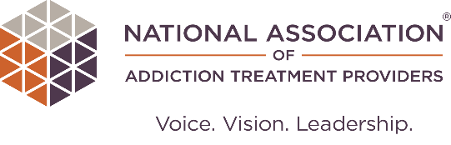

Treatment Provider COVID-19 Impact Survey

Dear Brett,
NAATP is collecting data on how the COVID-19 health crisis has impacted SUD treatment providers, including revenue, staffing, patient services, and levels of staff vaccination. This is a follow-up survey, to compare with results of our first survey which were published in October 2020. Please take a few minutes to complete this short survey. Results will be published in November 2021. Data will be used to support our members, and advocate for relief policies that ensure continued availability of SUD treatment services during and after the health crisis.
Thank you for your participation,
Peter Thomas
Director of Quality Assurance
pthomas@naatp.org | 303.835.9034

Complete COVID-19 Impact Survey

National Association of Addiction Treatment Providers
1120 Lincoln Street, Suite 1104
Denver, CO 80203
United States
info@naatp.org | 888.574.1008 | naatp.org
This email was intended for brettb@thenationalcouncil.org.

COMPLETE COVID-19 TREATMENT PROVIDER SURVEY

